**INDIA’S AGRICULTURAL CROP PRODUCTION (1997 - 2021)**

* 1. **Introduction:**

Agriculture is the backbone of the Indian economy. India ranks second worldwide in farm output. Transformed from food shortage and import to self-sufficient food production and export market.

Agriculture helps to meet the basic needs of human and their civilization by providing food, clothing. The Indian government has introduced schemes and initiatives to support farmers.

* 1. **Overview:**

In this project, we discuss crop production. First, we can analyze crop production in India by linking data with tableau software. We also discuss the benefits and applications in crop production.

* 1. **Purpose:**

Analyzing crop production helps ensure an adequate food supply for the Country’s growing population. It aids in economic planning and budget allocation by Understanding the contribution of agriculture to the GDP (Gross Domestic Product). Crop analysis helps in formulating Agriculture policies, Subsidies, and incentives for farmers.

It plays a role in determining the export potential of crops, contributing to Foreign exchange earnings. Crop analysis can help improve farmer’s income by optimizing Crop selection and yield –enhancing techniques. It guides research and development Efforts in agriculture, including the development of new crop varieties.

* 1. **Problem definition and design thinking**

**2.1 Empathy map:**

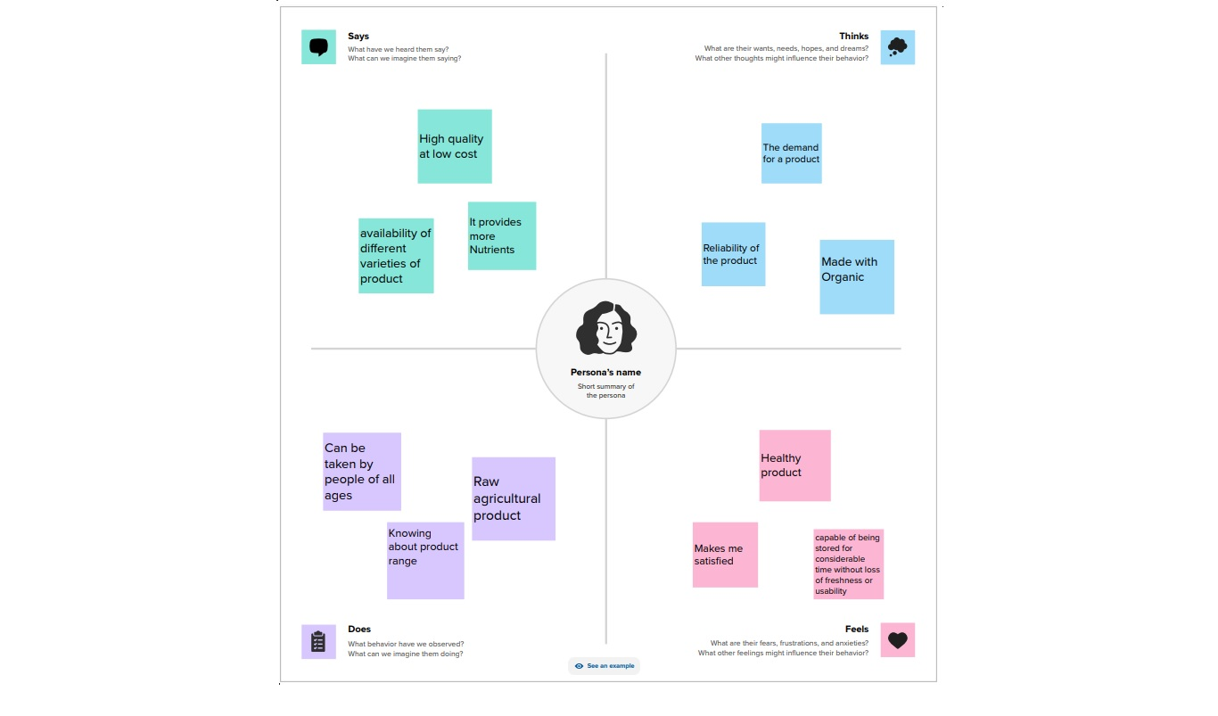

**2.2 Ideation and Brain storming map:**

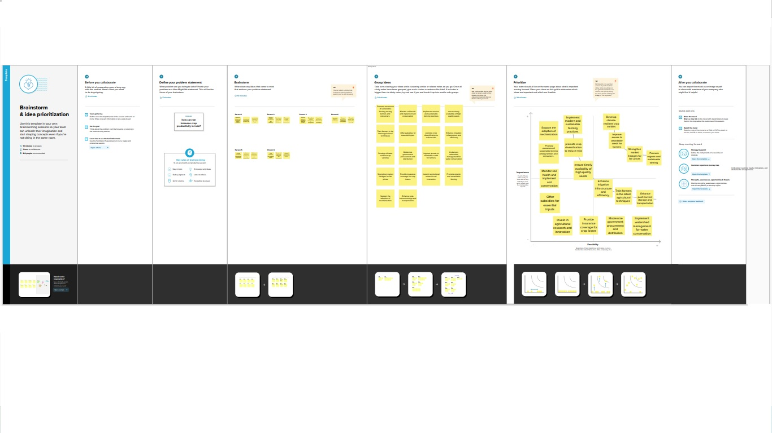

* 1. **Result**

**State Wise Agricultural land:**

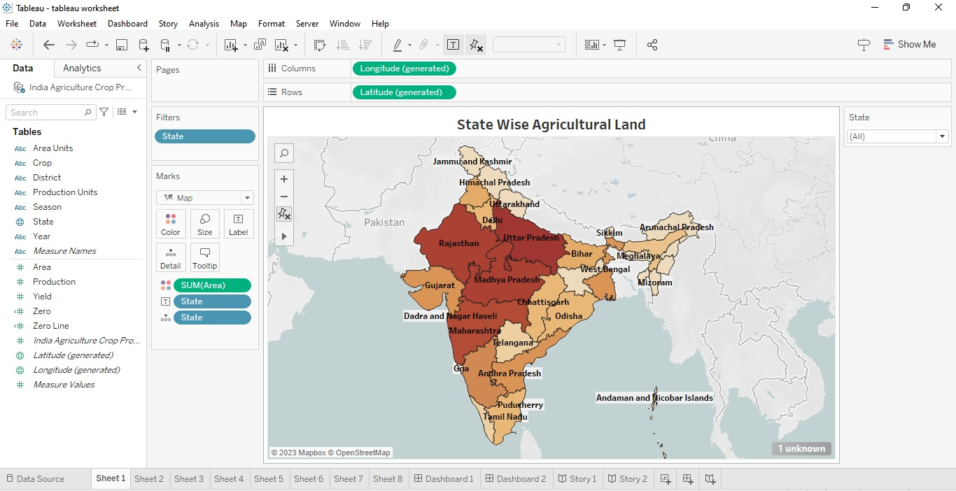

**Area Vs Production:**

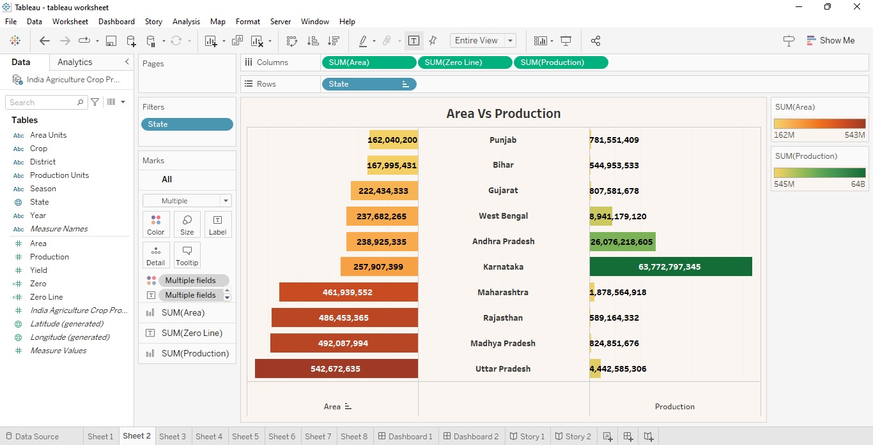

**Season Based Cultivation Area:**

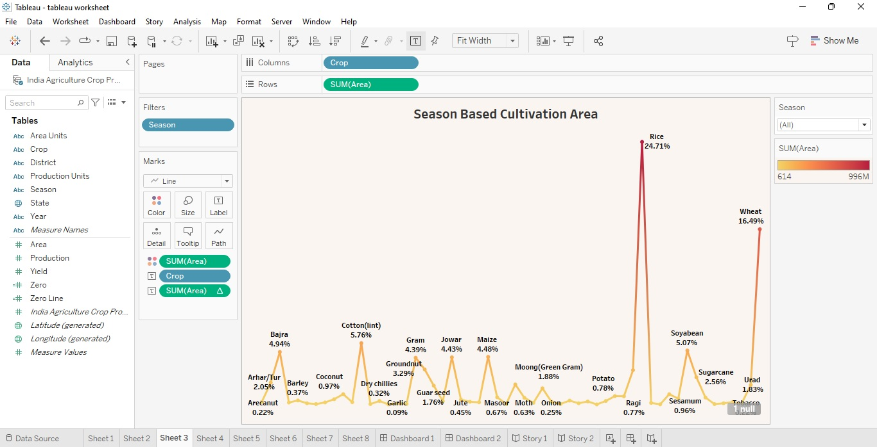

**Yield by Season:**

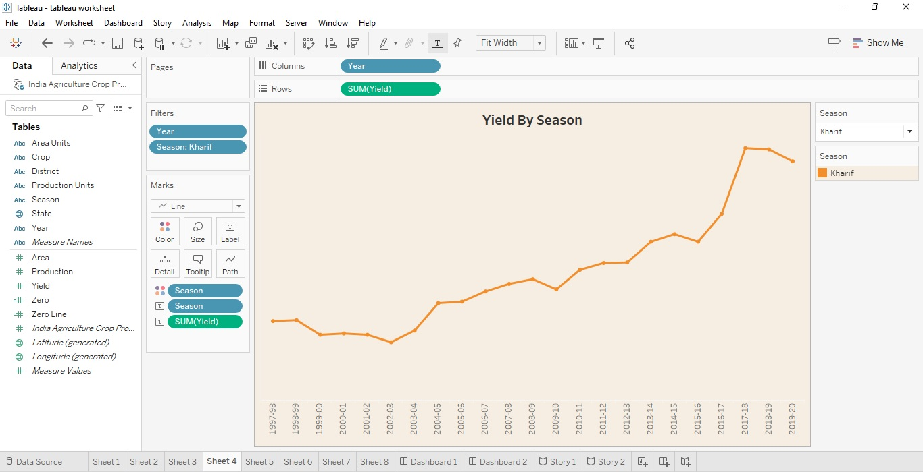

**Crop Plantation by Area:**

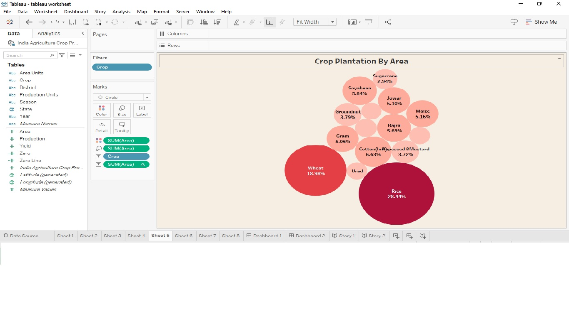

**Major Crops:**

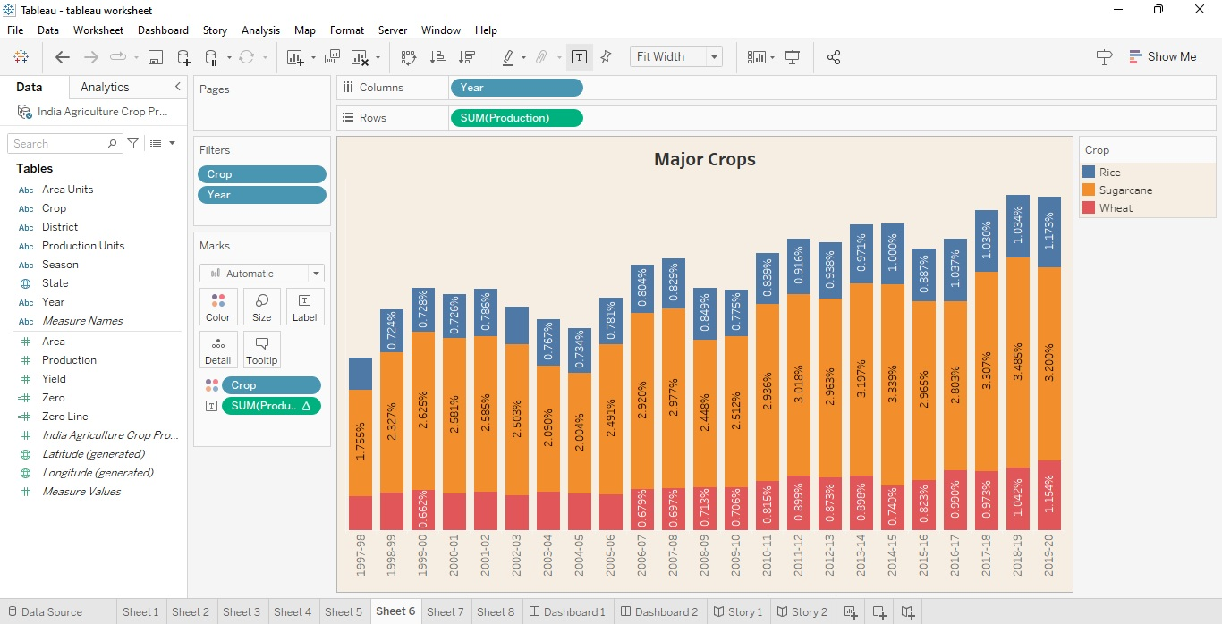

Crops (Plantation By Count):

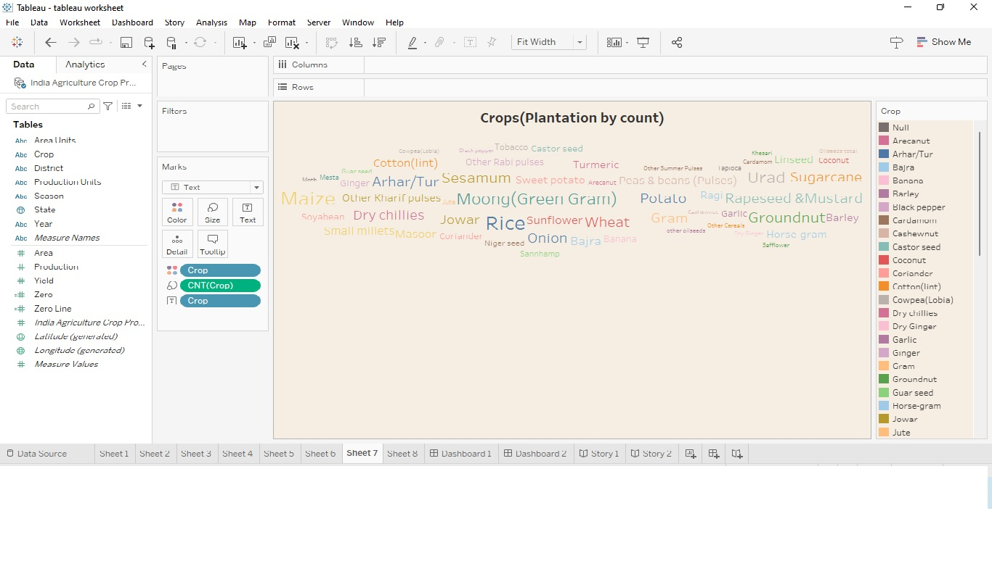

**Season Wise Production:**

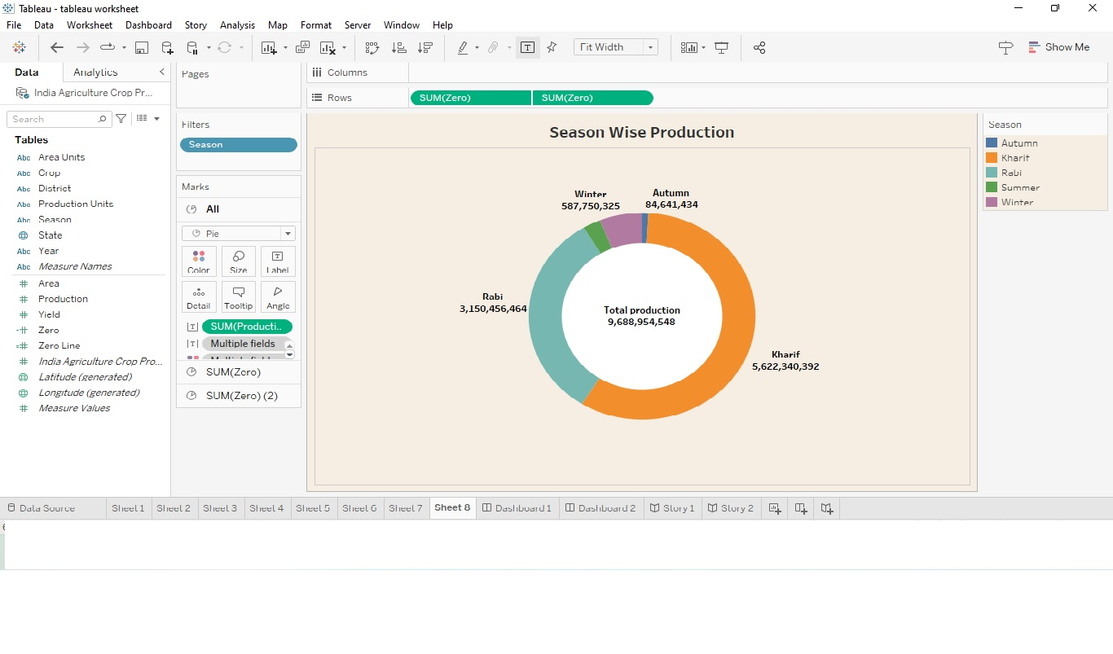

**Dashboard 1:**

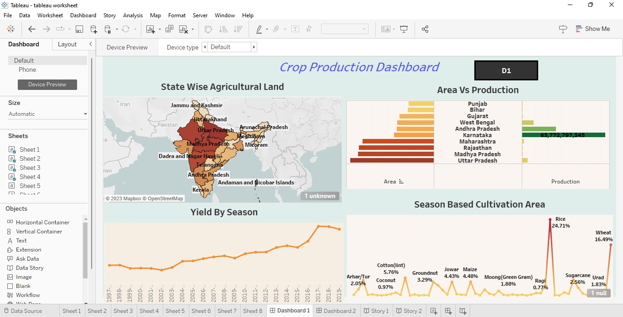

**Dashboard 2:**

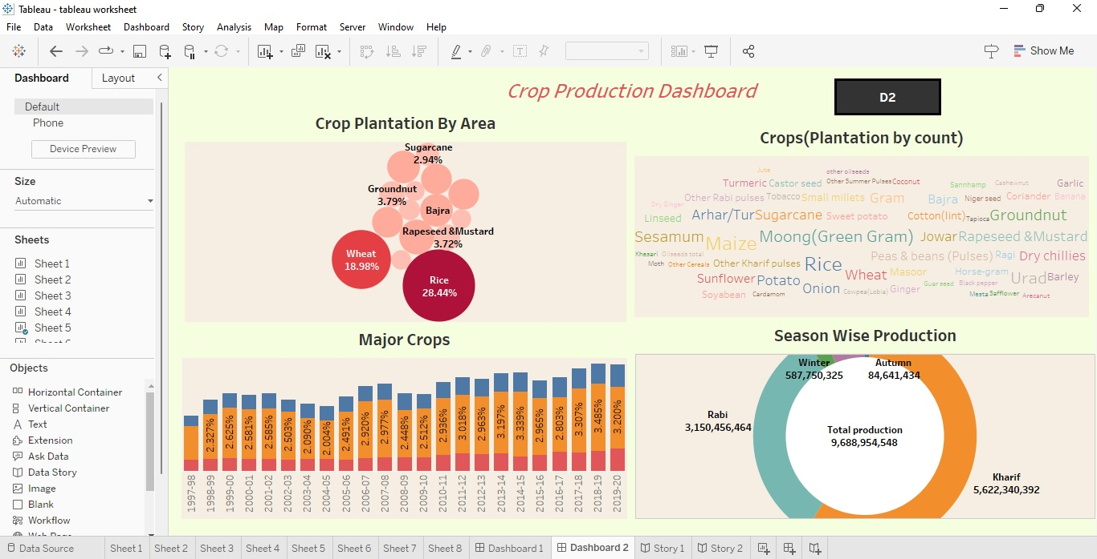

**Story 1:**

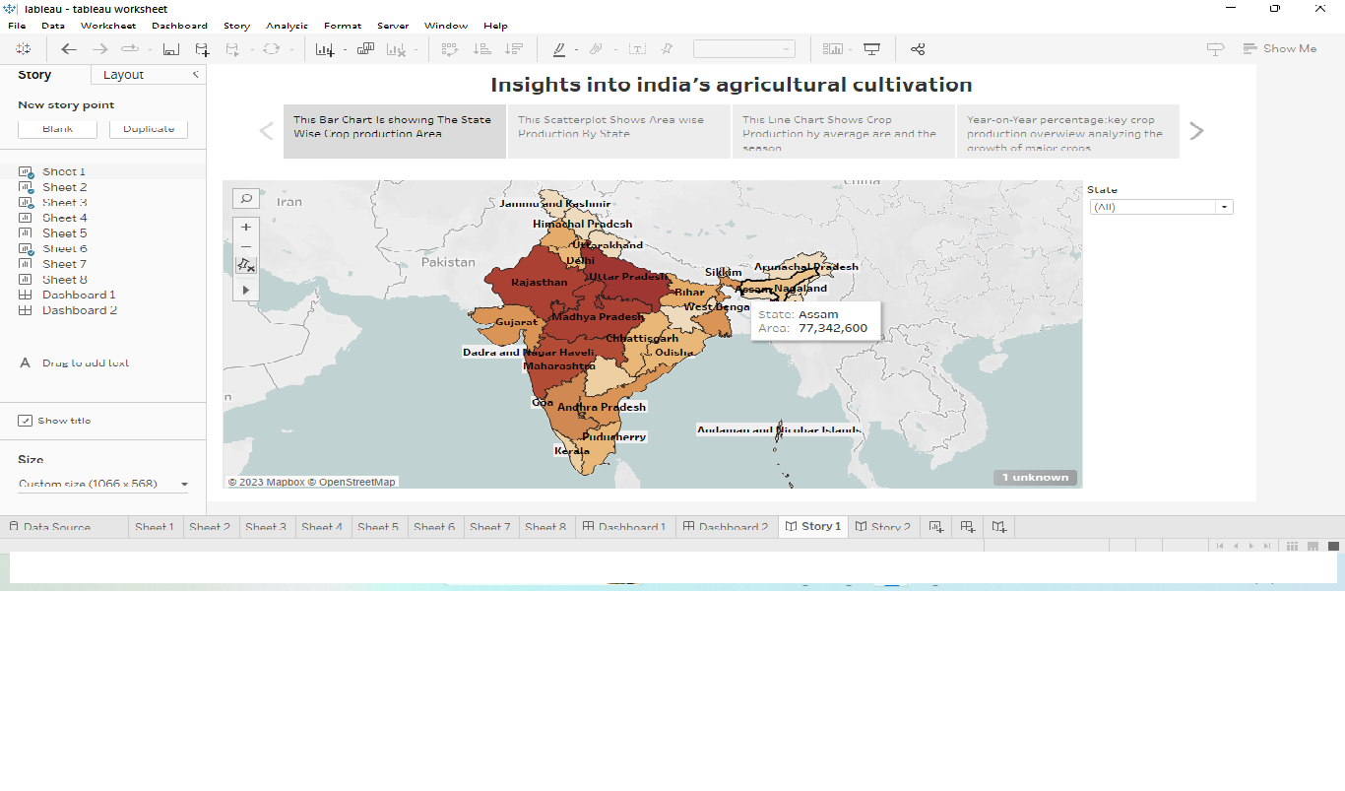

**Story 2:**

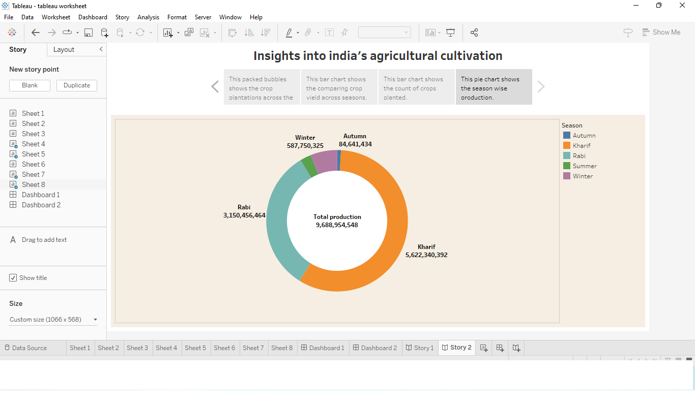

* 1. **Advantages & Disadvantages**

**Advantages:**

* Agriculture is the practice of that farming in which crops are grown for trade.
* Plantation agriculture takes advantage of economies of scale which is an economic concept that increased level of production.
* It helps estimate future crop yields, allowing for better planning and resource allocation.
* Enables efficient use of resources like water, fertilizer, and land to maximize productivity and minimize waste.
* Contributes to food security by ensuring consistent crop production and reducing food shortages.
* Providing raw materials for food and other products.
* Encourages farmers to diversify into high-value crops.

**Disadvantages:**

* Crop production analysis heavily release an accurate and up-to-date data. In many regions, obtaining such data can be challenging, leading to potential inaccuracies.
* Variability in Weather patterns can lead to unpredictable outcomes, making long-term prediction difficult.
* Crop prices are subject to market forces, and analyzing crop production alone may not account for price fluctuations that affect farmer’s profitability.
* Crop production analysis is a complex, multidisciplinary field, and simplification oversights can lead to incomplete or misleading conclusions.
* Small land holdings limiting modernization.
* Marketing challenges and price volatility.
* Soil degradation and nutrient depletion.
  1. **Applictions:**

Farmers use crop production analysis to optimize planting, irrigation, and harvesting schedules, as well as to manage resources efficiently. Researchers use crop production analysis to study trends, develop new farming techniques, and create disease-resistant crop varieties. These services provide advice and information to farmers helping them make data-driven decisions regarding crop management.

Crop insurance providers use analysis to assess and validate insurance claims related to crop loses. Traders and investors use crop production analysis to predict market trends and make informed decisions about commodity trading.

* 1. **Conclusion:**

In this project, we conclude the data in tableau software and we can analyze the data’s related to agricultural crop production analysis. we can analyze the data’s like seasonal cultivation, production area, Season wise production, yield by season, Major crops and state wise agriculture land.

On overall view, India has always been benefited by agriculture. Integrated farming system seems to be the answer to the problems of increasing food production, for increasing income and for improving nutrition of the small scale farmers with limited resources without any adverse effect on environment.

The Government, have to step up efforts to make a positive and equitable differences in the lives of the farmers and make an agriculture occupy a pride of a place in the Nation's Economy.

Though the future of India is industrialization, the contribution of agriculture would always prove to be vital for making India a powerful& stable economy in the future.

* 1. **Future Scope:**

Analyze historical and current crop yields to assess production trends and variations over time. Evaluate soil properties including nutrient content, PH levels and texture to understand how soil conditions impact crop output. Analyze irrigation methods and water usage, which play a vital role in arid and semi-arid regions.

Study farming techniques, machinery usage and adoption of modern technology to identify opportunities for improvement. Study consumer preferences and trends, which can influence crop choices and market demand.